Malawi

## GNI per capita and development level

The data set shows the GNI per capita and development level of the country each year.

## # A tibble: 19 x 5  
## country iso3c date GNIperCapita devCategory   
## <chr> <chr> <dbl> <dbl> <chr>   
## 1 Malawi MWI 1996 40367. High Income   
## 2 Malawi MWI 1998 1056. Lower Middle Income  
## 3 Malawi MWI 2000 1079. Lower Middle Income  
## 4 Malawi MWI 2002 357. Low Income   
## 5 Malawi MWI 2003 368. Low Income   
## 6 Malawi MWI 2004 378. Low Income   
## 7 Malawi MWI 2005 382. Low Income   
## 8 Malawi MWI 2006 389. Low Income   
## 9 Malawi MWI 2007 417. Low Income   
## 10 Malawi MWI 2008 436. Low Income   
## 11 Malawi MWI 2009 457. Low Income   
## 12 Malawi MWI 2010 471. Low Income   
## 13 Malawi MWI 2011 481. Low Income   
## 14 Malawi MWI 2012 472. Low Income   
## 15 Malawi MWI 2013 479. Low Income   
## 16 Malawi MWI 2014 494. Low Income   
## 17 Malawi MWI 2015 489. Low Income   
## 18 Malawi MWI 2016 504. Low Income   
## 19 Malawi MWI 2017 497. Low Income

## GDP growth and economic growth classification

The data set shows the GDP growth and the ecomic growth classification of the country each year.

## # A tibble: 19 x 5  
## country iso3c date GDPannualGrowthRate GDPgrowthCategory4  
## <chr> <chr> <dbl> <dbl> <fct>   
## 1 Malawi MWI 1996 7.32 fast growth   
## 2 Malawi MWI 1998 3.90 moderate growth   
## 3 Malawi MWI 2000 1.58 slow growth   
## 4 Malawi MWI 2002 1.70 slow growth   
## 5 Malawi MWI 2003 5.71 fast growth   
## 6 Malawi MWI 2004 5.42 moderate growth   
## 7 Malawi MWI 2005 3.27 moderate growth   
## 8 Malawi MWI 2006 4.70 moderate growth   
## 9 Malawi MWI 2007 9.60 fast growth   
## 10 Malawi MWI 2008 7.64 fast growth   
## 11 Malawi MWI 2009 8.33 fast growth   
## 12 Malawi MWI 2010 6.87 fast growth   
## 13 Malawi MWI 2011 4.85 moderate growth   
## 14 Malawi MWI 2012 1.89 slow growth   
## 15 Malawi MWI 2013 5.20 moderate growth   
## 16 Malawi MWI 2014 5.70 fast growth   
## 17 Malawi MWI 2015 2.80 moderate growth   
## 18 Malawi MWI 2016 2.48 slow growth   
## 19 Malawi MWI 2017 4.00 moderate growth

## Development trend

The plot shows the development trend of the country.

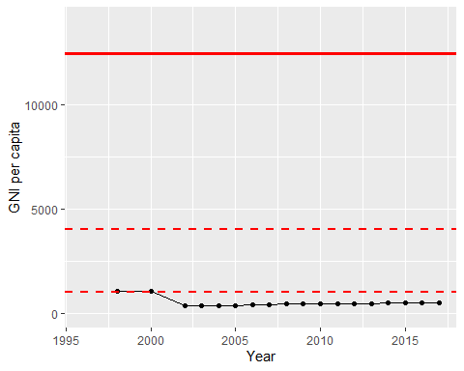

GNI Per Capita Trend